WEEK08–CODING

**Question1**:

Codershereisasimpletaskforyou,youhavegivenanarrayofsizeNandanintegerM.Yourtaskis tocalculatethedifferencebetweenmaximumsumandminimumsumofN-Melementsofthegiven array.

Constraints:

1<=t<=101<=n<=10001<=a[i]<=1000

Input:

FirstlinecontainsanintegerTdenotingthenumberoftestcases.Firstlineofeverytestcasecontains two integer N and M. Next line contains N space separated integers denoting the elements of array

Output:

Foreverytestcaseprintyouranswerinnewline SAMPLE INPUT

1

51

12 345

SAMPLEOUTPUT 4

Explanation

Mis1andNis5soyouhavetocalculatemaximumandminimumsumusing(5-1=)4elements. Maximum sum using the 4 elements would be (2+4+5=)14. Minimum sum using the 4 elements

wouldbe(1+2+3+4=)10.Differencewillbe14-10=4

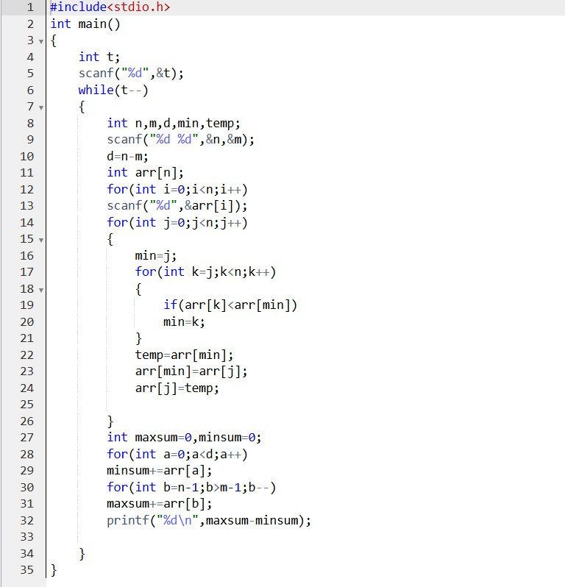

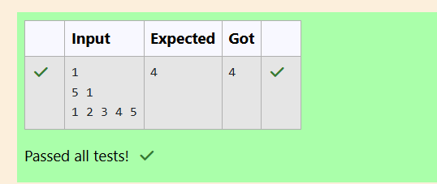

**Question2**

Anewdeadlyvirushasinfectedlargepopulationofaplanet.Abrilliantscientist has discovered a new strain of virus which can cure this disease. Vaccine produced from this virus has various strength depending on midichlorians count. A person is cured only if midichlorians count in vaccine batch is more than midichlorians count of person. A doctor receives a new set of report

whichcontainsmidichlorianscountofeachinfectedpatient,Practostoresall vaccine doctor has and their midichlorians count. You need to determine if doctorcansaveallpatientswiththevaccineshehas.Thenumberofvaccines and patients are equal.

InputFormat

Firstlinecontainsthenumberofvaccines-N.SecondlinecontainsNintegers, which are strength of vaccines. Third line contains N integers, which are

midichlorianscountofpatients. Output Format

Printasinglelinecontaining'Yes'or'No'. Input Constraint

1<N <10

Strengthofvaccinesandmidichlorianscountofpatientsfitininteger. SAMPLE INPUT

5

123146454542456

100328248689200

SAMPLEOUTPUT

No

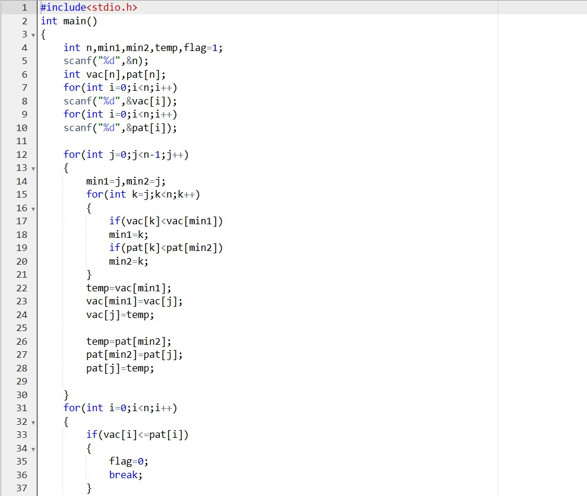

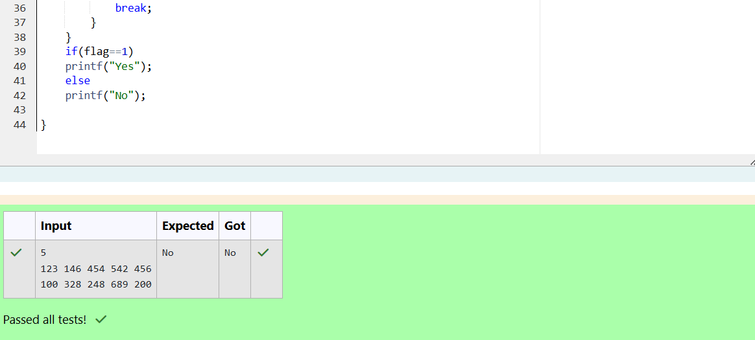

# Question3

Youaregivenanarrayofnintegernumbersa1,a2,...,an.Calculate thenumberofpairofindices(i,j)suchthat1≤i<j≤nandaixoraj= 0.

Inputformat–

Firstline:ndenotingthenumberofarrayelements-

Secondline:nspaceseparatedintegersa1,a2,...,an. Output format

Outputtherequirednumberofpairs. Constraints

1≤n ≤106

1≤ai≤ 109

## SAMPLEINPUT 5

13143

## SAMPLEOUTPUT 2

Explanation

The2pairofindicesare(1,3)and(2,5)

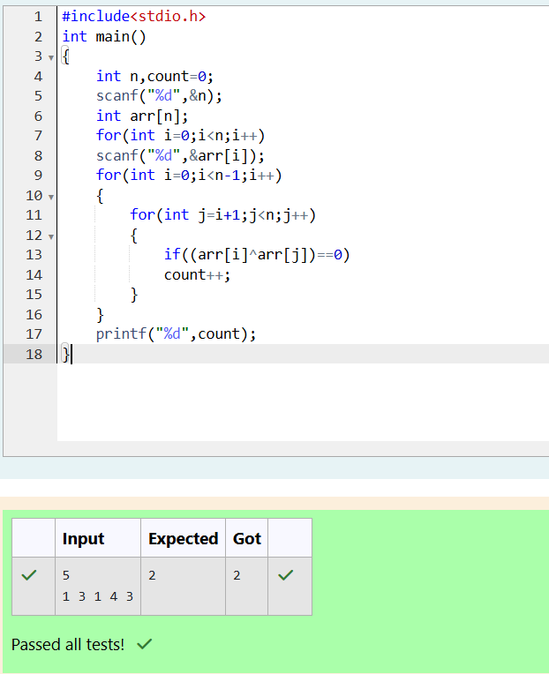

# Question4

YouaregivenanarrayAofnon-negativeintegersofsizem.Yourtask istosortthearrayinnon-decreasingorderandprintouttheoriginal indices of the new sorted array.

Example:A={4,5,3,7,1}

AftersortingthenewarraybecomesA={1,3,4,5,7}.Therequired output should be "4 2 0 1 3"

## INPUT:

Thefirstlineofinputconsistsofthesizeofthearray The next line consists of the array of size m

## OUTPUT:

Outputconsistsofasinglelineofintegers CONSTRAINTS:

1<=m<=106

0<=A[i]<=106

NOTE:Theindexingofthearraystartswith0. SAMPLE INPUT

5

45371

SAMPLEOUTPUT 4 2 0 1 3

